TITLE

First Author Name SURNAME
ORCID:xxxx-xxxx-xxxx-xxxx
Institution, COUNTRY

Second Author Name SURNAME
ORCID:xxxx-xxxx-xxxx-xxxx
Institution, COUNTRY

Third Author Name SURNAME
ORCID:xxxx-xxxx-xxxx-xxxx
Institution, COUNTRY

(First and secondary author name should be 10 Point, ARIAL and Capitalize Each Word SURNAME should be uppercase, aligned right).

ABSTRACT

An informative, comprehensive abstract of 200 to 250 words must also be submitted and typed on a separate page. This abstract should summarize the major points of the paper, and the author's summary and conclusions. The abstract should not contain any undefined abbreviations or unspecified references. Start the abstract with the sequence "ABSTRACT" (without the quotes and in capital letter) and leave 1 blank line after the abstract.

Keywords: The, manuscript, should, provide 4-7, keywords, which, will be, used for, indexing purposes.

INTRODUCTION

Introduction should be 10 point, ARIAL, bold, blue, uppercase, aligned left. All manuscripts are acknowledged upon receipt. All submitted manuscripts are reviewed for compliance with the GLOKALde initially by editor(s). The submitted manuscripts are sent to at least two reviewers (blind). Based on reviewers’ evaluations, the responsible editor(s) will accept or reject the submitted manuscripts. The overall review process including peer-review, revision of the manuscript, and the final decision is completed within at least three months.

When a decision for publication or rejection is made, the author designated to receive correspondence is notified. At the time of notification, the author may be asked to make certain revisions in the manuscript, or the Editor may submit suggested revisions to the author for approval.

Articles must be sent as an attachment at glokal.editor@gmail.com by corresponding authors. Microsoft WORD is the preferred word processor format. Written manuscripts should be in English. The manuscript must conform to the style of the Publication Manual of the American Psychological Association (APA), 7th Edition https://apastyle.apa.org/products/publication-manual-7th-edition Manuscripts should be single-spaced. All body text is must be ARIAL in 10 pt, justified. One line between paragraphs, no paragraph indents.

RUNNING TEXT TITLE BOLD BLUE UPPERCASE ALIGNED LEFT

All the titles and abstract should be ARIAL 10 pt., bold, blue, uppercase, aligned left. The body of the paper must begin immediately after the title. Leave 2 blank lines after title. Subtitles should be in ARIAL 10 pt., bold, blue, uppercase aligned left.

In general, manuscripts must be between 10 and 15 single-spaced pages including the references, figures, and tables. Research Briefs and Notes for Editor, Reviews may be shorter, normally between 03 –15 pages. Use italic print to emphasize words (Bold type and underlining must be avoided). The text must always be justified to occupy the full line width, so that the right margin is NOT ragged. Leave 1 blank lines at the end of each paragraph.

Ipsum lorem ipsum lorem ipsum lorem ipsum lorem ipsum lorem ipsum lorem ipsum lorem ipsum lorem ipsum lorem ipsum lorem ipsum lorem ipsum lorem ipsum lorem ipsum lorem ipsum lorem ipsum lorem ipsum lorem ipsum lorem ipsum lorem ipsum lorem ipsum lorem ipsum lorem ipsum lorem ipsum lorem ipsum lorem ipsum lorem ipsum.

First Level Subtitle Bold Blue Each Word Capitalized

First level subtitles are bold blue each word capitalized and aligned left. Ipsum lorem ipsum lorem ipsum lorem ipsum lorem ipsum lorem ipsum lorem ipsum lorem ipsum lorem ipsum lorem ipsum lorem ipsum lorem ipsum lorem ipsum lorem ipsum lorem ipsum lorem ipsum lorem ipsum lorem ipsum lorem ipsum lorem ipsum lorem ipsum lorem ipsum lorem ipsum lorem ipsum lorem ipsum lorem ipsum lorem ipsum.

Second level subtitle bold blue

Second level subtitles are bold, blue, each word lower case and aligned left. Ipsum lorem ipsum lorem ipsum lorem ipsum lorem ipsum lorem ipsum lorem ipsum lorem ipsum lorem ipsum lorem ipsum lorem ipsum lorem ipsum lorem ipsum lorem ipsum lorem ipsum lorem ipsum lorem ipsum lorem ipsum lorem ipsum lorem ipsum lorem ipsum lorem ipsum lorem ipsum lorem ipsum lorem ipsum lorem ipsum lorem ipsum.

Third level subtitle bold blue and italic

Third level subtitles are bold, blue, each word lower case and aligned left. Ipsum lorem ipsum lorem ipsum lorem ipsum lorem ipsum lorem ipsum lorem ipsum lorem ipsum lorem ipsum lorem ipsum lorem ipsum lorem ipsum lorem ipsum lorem ipsum lorem ipsum lorem ipsum lorem ipsum lorem ipsum lorem ipsum lorem ipsum lorem ipsum lorem ipsum lorem ipsum lorem ipsum lorem ipsum lorem ipsum lorem ipsum.

Fourth level subtitle bold blue and italic
Fourth level subtitles are indented, bold, blue, each word lower case and aligned left. Ipsum lorem ipsum lorem ipsum lorem ipsum lorem ipsum lorem ipsum lorem ipsum lorem ipsum lorem ipsum lorem ipsum lorem ipsum lorem ipsum lorem ipsum lorem ipsum lorem ipsum lorem ipsum lorem ipsum lorem ipsum lorem ipsum lorem ipsum lorem ipsum lorem ipsum lorem ipsum lorem ipsum lorem ipsum lorem ipsum lorem ipsum.

TABLES, FIGURES, EQUATIONS

Illustrations and tables should be progressively numbered, following the order cited in the text. Tables must be accompanied by a caption placed at the top, centered.

Table 1. XXXXXXXXXXXX
Item | Style (from "Style and Formatting")

When inserting figures, they should be as clear as possible. Figures must be centered. Do not use font sizes smaller than 8 ARIAL, as they will be difficult to be read. Figures must be accompanied by a caption placed underneath with Figure Caption X Bold.

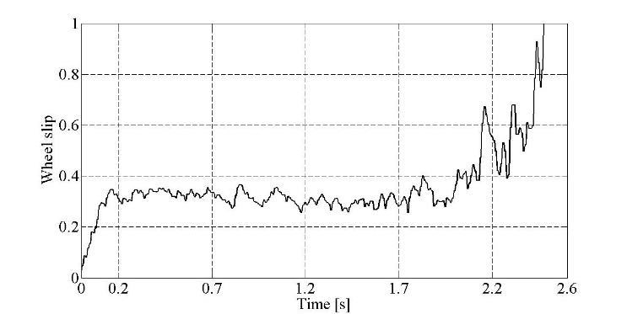

Figure 1. XXXXXXXXXXXXX

Color pictures are also acceptable, but you have to be sure they will be also visible on grayscale printing. Online version of the paper will be in color version. Pictures must be centered, accompanied by a caption placed underneath with Picture Caption X Bold.

Picture 1. XXXXXXXXXXXXXX

ACKNOWLEDGMENTS

This is an optional section. Acknowledgments or appreciation to individuals for assistance with the manuscript or with the material reported should be included as a note to appear at the end of the article prior to the References. Leave 2 blank lines after acknowledgments.

REFERENCES

Reference must conform to the style of the Publication Manual of the APA 7th Edition. Start the reference(s) with the sequence "REFERENCES" (without the quotes) in 10 point bold-face ARIAL, blue,
aligned left and leave 1 blank line after "REFERENCE" with capital in blue color.

Aldabbus, S. (2018). Project-based learning: Implementation & challenges. International Journal of Education, Learning and Development, 6(3), 71-79.
Belwal, R., Belwal, S., Sufian, A.B., & Al Badi, A. (2020). Project-based learning (PBL): outcomes of students' engagement in an external consultancy project in Oman. Education and Training, 63(3), 336-359.
Boone, H. N., & Boone, D. A. (2012). Analyzing likert data. Journal of Extension, 50(2), 1-5.
Bryman, A. and Cramer, D., (1997). Quantitative data analysis with SPSS for Windows: A guide for social scientists. London: Routledge.

BIODATA and CONTACT ADDRESSES of the AUTHOR/S

- Start with your full name followed by your current position, your general interests, and your current project, keeping them all very brief.
- If you are within a year of receiving a prestigious award, mention that as well.

What You Should Avoid?
- Avoid speaking in the first person, i.e., don’t use “I.”
- Don’t divulge details beyond your current position.
- In a longer bio of multiple paragraphs, you may add more awards and information about your master’s and bachelor’s degrees, but not in a short bio. Moreover, don’t add anything that happened before grad school including your place of birth.

Author Name (Academic Title)
Contact Addresses
Phone Office
E-mail (contact e-mail)
URL (personal website or your personal institution web page)

